INSTRUCTIONS TO MAKE ONLINE PAYMENT WITH
TECHCOMBANK CARD

A/ ACTIVATE ONLINE PAYMENT FUNCTION:
Register F@ss i- Bank Service at Techcombank Transaction Counters.
Note: Techcombank only support transaction with Internet Explorer web browser.
B/ INTRUCTION TO MAKE ONLINE PAYMENT
Step 1: Good/service selection and Online Payment with Domestic Debit Card
After you have selected the product and/ or service, please select “ Pay by domestic debit card”
Select logo Techcombank to make the payment.
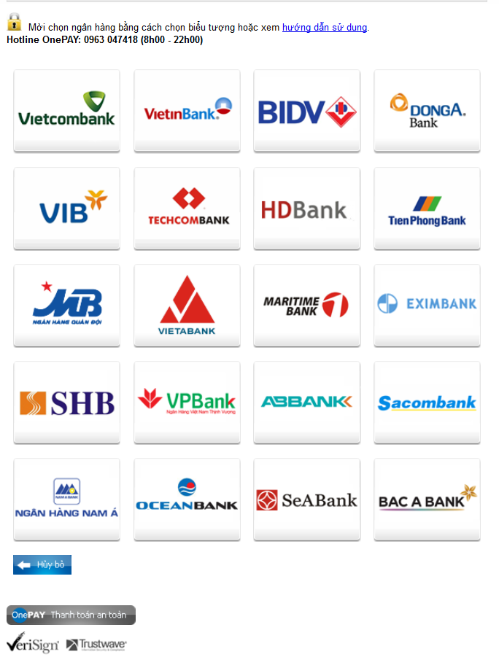

Step2: Login F@ss i-Bank account:

- Login your F@ss i-Bank account
User name: You get this user name after registering F@ss i-Bank
Password: there are 2 options:
If you choose to receive OTP through SMS (without Token key):
The password is the one provided when registering F@st i-bank.
If you choose: include 2 parts: The password you get when you register F@ss i-Bank and 6 digital submitted by Tocken Key.
Click “ LOGON”
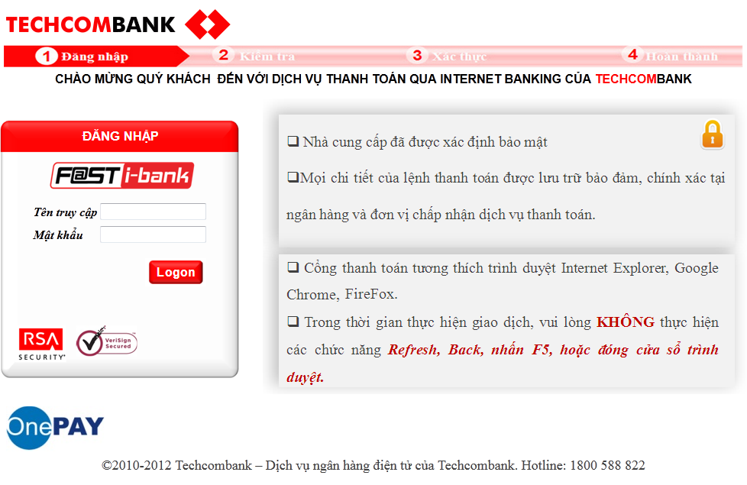
- Transaction details:
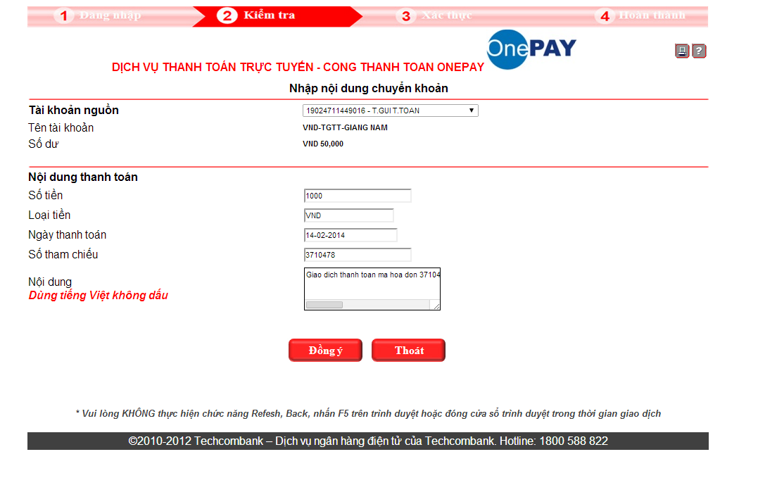
Click “Đồng ý”

- Payment Confirmation:
Click “OK” in Payment Confirmation box.
Recheck order information and click “Đồng ý”
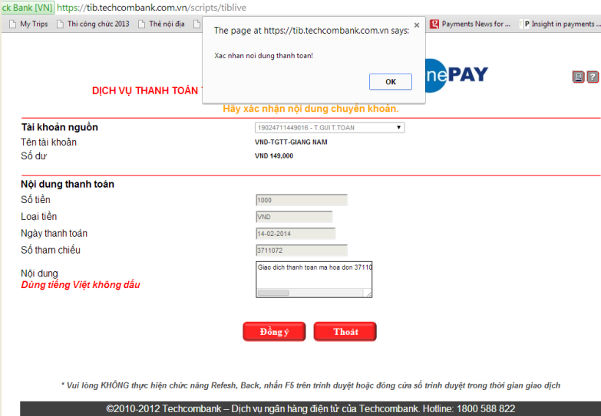
Step3: Card-Holder verification:
Input F@st i- Bank password (include 2 parts: The password you get when you register F@ss i-Bank and the password sent to you through SMS or generated by Token key at that moment in verification box.
Click “ SUBMIT”
Note: You need to input correctly the personal password + the password (sent to you by SMS / generated by Token key at that moment). Token code will be submitted from Tocken Key for every minute. You have to input correct password at that momment.
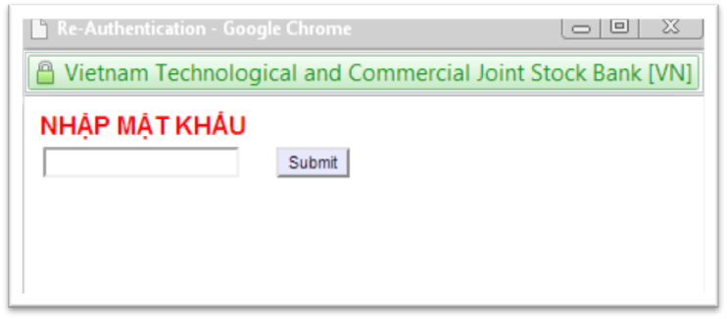
Step 4: Transaction Result
After completing the payment steps, you will receive the transection result.

